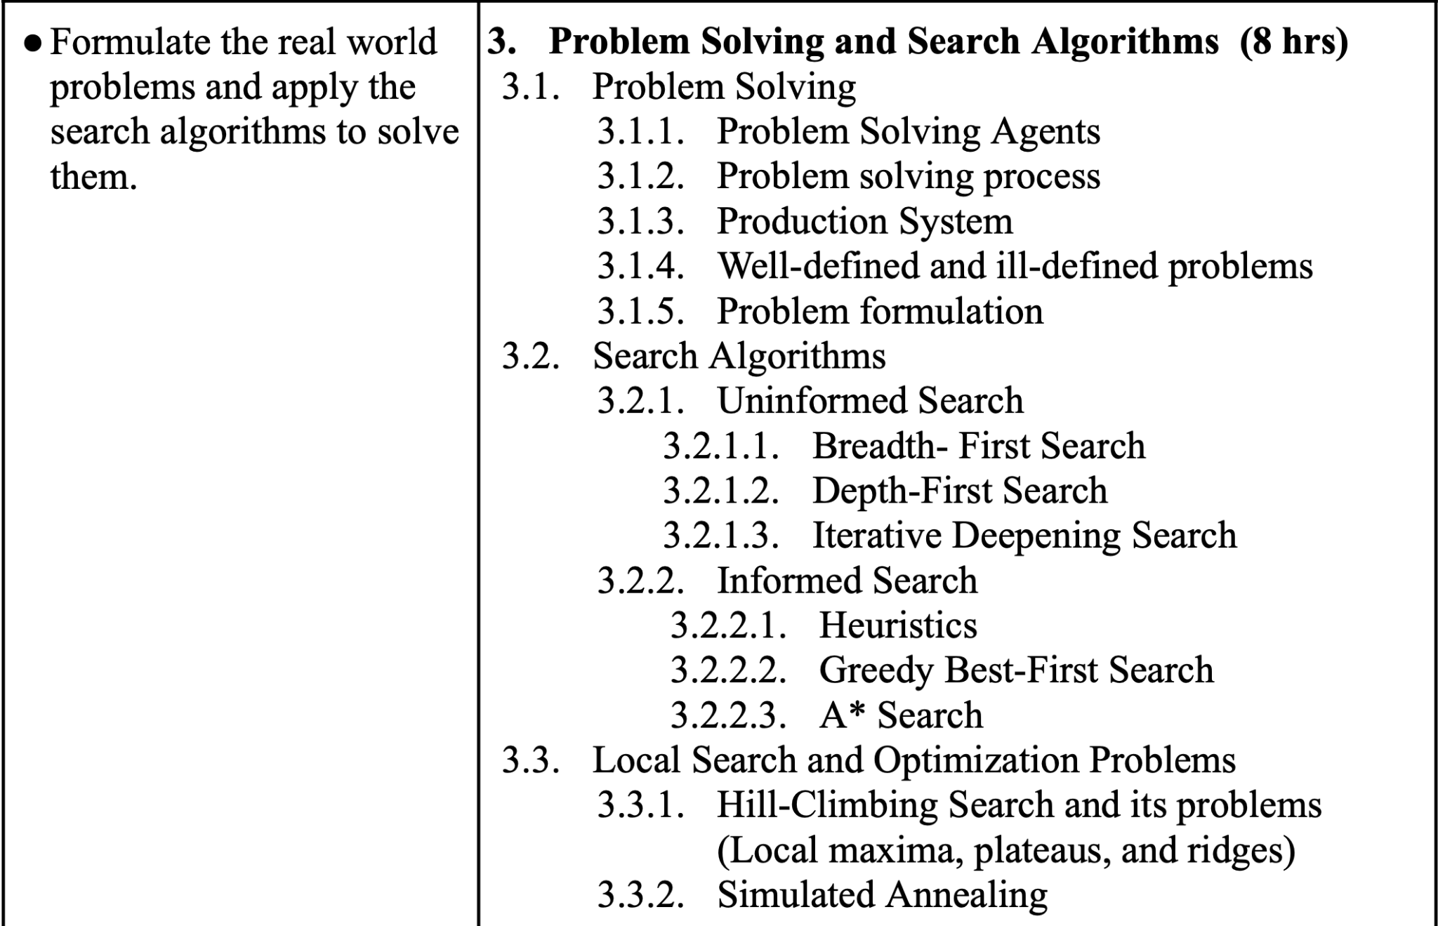



1. What are the different types of problems? Discuss the necessary steps in problem solving. Explain problem formulation with examples.
2. What do you mean by State Space representation of a problem? Use the Production Rule System to solve the river crossing problem where “A farmer has a FOX, a GOAT, and a CABBAGE”.
3. Discuss different types of search algorithms. Compare and contrast the Breadth-First Search (BFS) and Depth-First Search (DFS) algorithms.
4. What is the use of search algorithms in AI? Discuss the role of heuristics in informed search algorithms, and explain the working of the Greedy Best-First Search algorithm.
5. Describe the concept of Iterative Deepening Search and explain how it combines the benefits of both BFS and DFS
6. Discuss the limitations of Hill-Climbing Search, particularly in the context of local maxima, plateaus, and ridges. Suggest the remedies for those limitations.
7. What is the concept behind MIN-MAX searching technique? Explain alpha-beta pruning by taking an appropriate example.